**Rashtreeya Sikshana Samithi Trust**

**RV UNIVERSITY**

**School of Computer Science and Engineering**

**Bengaluru – 560059**



**Lab Record**

**CS3234 - Foundations of Generative AI**

**VI SEMESTER B.Tech (Hons.)**

# Cybersecurity and Ethical Hacking Fundatmentals– Documentation

**Name:** Shashi Kumar R  
 **Program:** BTech CSE  
 **Institution:** R V University  
 **Workshop Date:** 15/02/2026  
 **Time:** 10:00 AM – 4:00 PM

## 1. Objective

To demonstrate an end-to-end workflow using Generative AI tools to create promotional content for a workshop, including:

* Launch email (text)
* Workshop poster (image)
* Promo video (video)

## 2. Tools Used

* ChatGPT / Gemini / Claude – email and text generation
* DALL-E / Image Creator – poster generation
* Fliki.ai – text-to-video promo creation
* Kaleido.ai – animated reel creation (optional)

## 3. Prompts Used

### Prompt 1: Launch Email (ChatGPT/Gemini/Claude)

Act as a professional academic coordinator and cybersecurity education expert. Create a formal workshop launch email suitable for academic circulation.

Workshop Topic: **Ethical Hacking and Network Security Basics**  
Target Audience: Undergraduate students and working professionals  
Duration: One-day (6 hours)  
Mode: Offline  
Location: Bengaluru  
Level: Beginner (no prior hacking, cybersecurity, or programming knowledge required)

The email must clearly include:

* Workshop objective and academic relevance
* Career importance of cybersecurity skills
* Date, time, mode, and location of the workshop
* Key topics covered (ethical hacking fundamentals, cyber threats, network security basics, introductory hands-on tools, career pathways)
* Registration details with a clear mention of **limited seats**
* Contact information (generic placeholders allowed)

Tone and Style Requirements:

* Professional, formal, and motivating
* Suitable for universities and academic institutions
* Avoid casual or promotional language
* Ensure clarity, structure, and credibility

Format and Length:

* Paragraph-based formal email
* Word limit: 180–200 words
* Clear opening, informative body, and polite academic closing

### Prompt 2: Poster Creation (DALL-E / Image Creator in Chatgpt)

Create a **high-resolution, professional digital poster** for a **university-level technical workshop** titled **“Cybersecurity & Ethical Hacking Fundamentals.”**

**Poster Content (Clearly Visible Text)**

* **Workshop Title:** Cybersecurity & Ethical Hacking Fundamentals
* **Date:** 25th March 2026
* **Time:** 10:00 AM – 4:00 PM
* **Mode:** Online Workshop
* **Organized by:** Department of Computer Science and Engineering

**Scene Description**

Depict **undergraduate engineering students** working on laptops in a **modern computer lab or virtual classroom environment**, with cybersecurity dashboards and code visible on screens, representing online technical learning.

**Visual Elements**

* Cybersecurity-themed graphics including **digital locks, shields, firewalls, encrypted code, network diagrams, and security icons**
* Abstract visual representation of **ethical hacking, intrusion detection, and security monitoring**
* Subtle **binary code patterns** and **digital network lines** in the background

**Design Constraints**

* Professional **academic and official university appearance**
* Clean **poster-style layout** suitable for college notice boards and online promotion
* **Blue and dark-blue color palette** with subtle glowing cyber highlights
* **Modern, futuristic technology aesthetic**
* Balanced composition with clean typography and clear hierarchy
* **High-resolution output** with sharp text and visuals

**Overall Tone**

Formal, trustworthy, and educational, designed for **official university promotion** and student outreach.

### Prompt 3: Promo Video Script (Fliki.ai)

**Video Style:** Professional, academic, technology-focused  
**Tone:** Formal, informative, motivating  
**Audience:** Undergraduate students & working professionals  
**Duration:** 60–90 seconds

**Scene 1 – Opening (Cyber Theme Introduction)**

**Visual:** Abstract cybersecurity visuals, digital locks, network lines, code flowing  
**Voiceover:**  
"Cybersecurity has become a critical skill in today’s digital world. With increasing cyber threats, understanding ethical hacking and network security is more important than ever."

**Scene 2 – Workshop Announcement**

**Visual:** Students and professionals working on laptops, classroom or seminar visuals  
**Voiceover:**  
"We are pleased to announce a one-day offline workshop titled *Ethical Hacking and Network Security Basics*, designed for beginners and aspiring cybersecurity professionals."

**Scene 3 – Target Audience**

**Visual:** University students, IT professionals, group learning environment  
**Voiceover:**  
"This workshop is open to undergraduate students and working professionals. No prior knowledge of hacking, cybersecurity, or advanced networking is required."

**Scene 4 – Workshop Objective**

**Visual:** Shield icons, secure servers, ethical hacker illustrations  
**Voiceover:**  
"The objective of this workshop is to provide a strong foundation in ethical hacking concepts, common cyber threats, and essential network security practices."

**Scene 5 – Key Topics Covered**

**Visual:** Icons or animations for attacks, networks, tools, career paths  
**Voiceover:**  
"Participants will learn the fundamentals of ethical hacking, types of cyber attacks, basic network security mechanisms, hands-on exposure to security tools, and career pathways in cybersecurity."

**Scene 6 – Date, Time & Location**

**Visual:** Calendar animation, clock, Bengaluru city visuals  
**Voiceover:**  
"The workshop will be held on Saturday, 15th February 2026, from 10 AM to 4 PM, as an offline session in Bengaluru."

**Scene 7 – Call to Action**

**Visual:** Registration button animation, limited seats highlight  
**Voiceover:**  
"Seats are limited. Interested participants are encouraged to register early to secure their spot."

**Scene 8 – Contact Information & Closing**

**Visual:** Email and phone icons, professional closing slide  
**Voiceover:**  
"For more information, contact us at [shashir@gmail.com](mailto:shashir@gmail.com) Join us and take your first step into the world of ethical hacking and network security."

## 5. Outputs (Attach or Insert)

* **Launch Email:** (paste email text here)  
  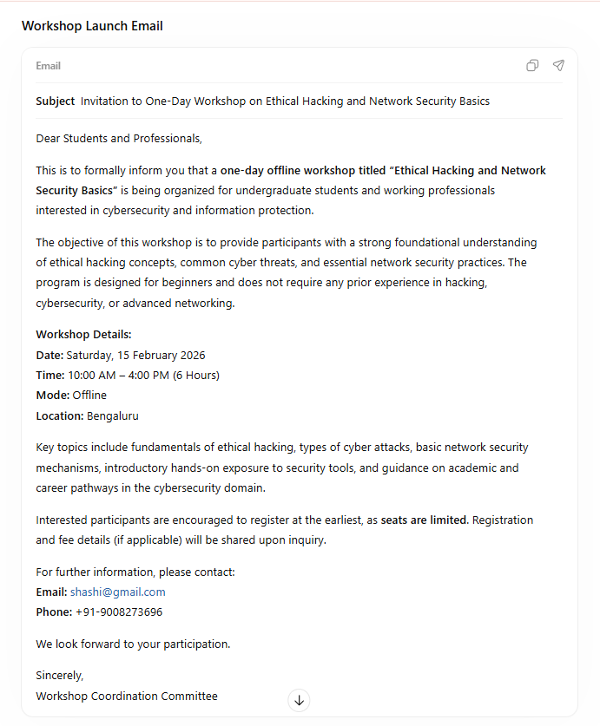
* **Poster Image:**

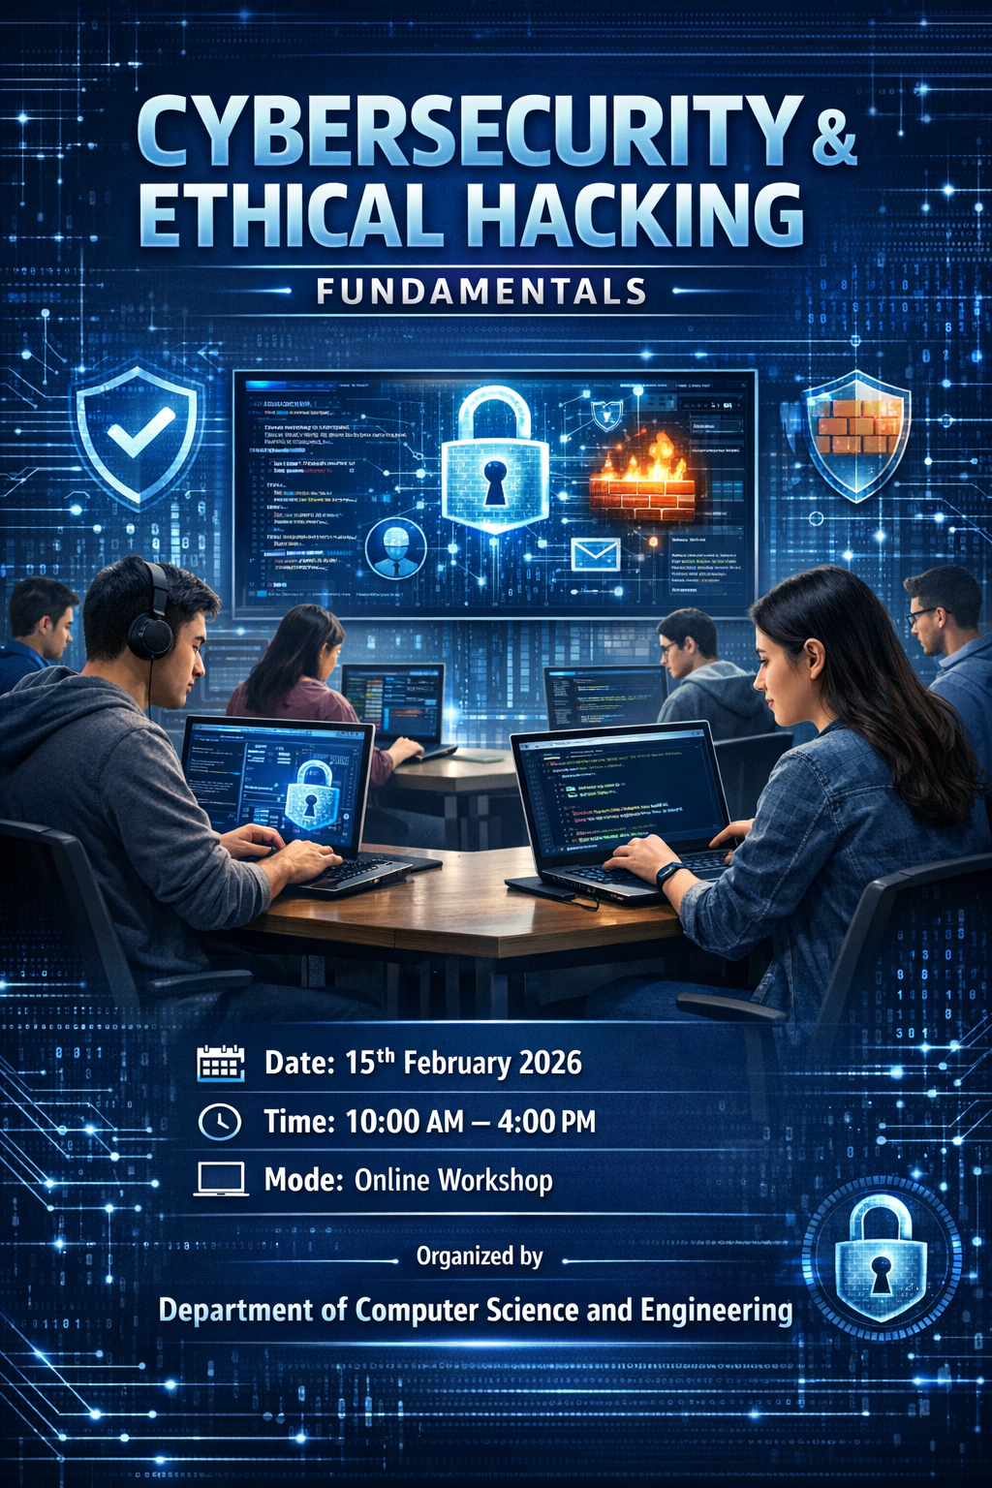

* **Promo Video:**

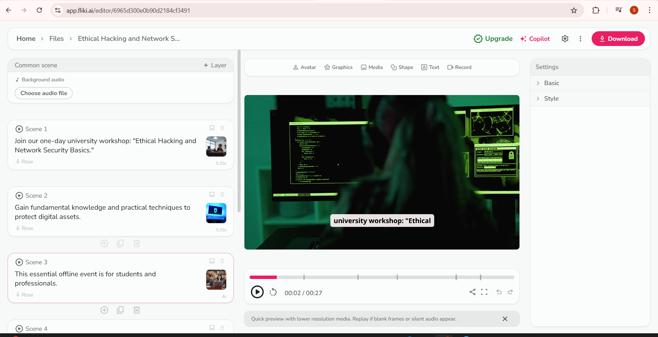

## 6. Conclusion

This documentation shows how Gen-AI tools can be used to generate text, image, and video assets for academic workshop promotion in an efficient and structured way.